**Product Requirements and Specifications Document**

**TERRALOGIC Learning Management System**

|  |  |
| --- | --- |
| **Project/ System** | Learning Management System |
| **Sub-Area/Module** | - |
| **JIRA/SNOW #** | - |

**Document Outline**

1. Overview 5

1.1. Reference Documents for PRD 8

2. Scope 8

2.1 In Scope Systems/Functionality 8

1.2. Assumptions and Out of Scope 9

High level Work breakdown 9

System Requirements and Specifications 10

1.3. Requirements – SW Applications (Mobile and Web Apps) 10

1.4. Requirements – Data Visualization and Analytics 11

1.5. Requirements – Server & Interfaces 12

1.6. Dependencies and ownership(Terralogic and Terralogic) 12

Key Phases for implementation 14

Design Overview 14

1.7. The use case sequence diagram 14

1.8. The high level Architecture & Geo deployment 15

1.9. Schema 16

1.10. API 17

**Revision History**

|  |  |  |  |
| --- | --- | --- | --- |
| **Version** | **Date Modified** | **Created/**  **Modified By** | **Action** |
| 0.1 | 25-Jul-2023 | Laiju V G | Initial Draft release |
| 0.2 |  |  |  |
|  |  |  |  |
|  |  |  |  |
|  |  |  |  |
|  |  |  |  |
|  |  |  |  |
|  |  |  |  |
|  |  |  |  |
|  |  |  |  |

**APPROVED BY**

1. Terralogic SW Solutions _____________________________ Date:

(NAME)

2. Terralogic ______________________________ Date:

(NAME)

**Acronyms**

|  |  |  |
| --- | --- | --- |
| **Sl. No** | **Short name** | **Description** |
| 1 |  |  |
| 2 |  |  |
| 3 |  |  |
| 4 |  |  |
| 5 |  |  |
| 6 |  |  |
| 7 |  |  |
| 8 |  |  |
| 9 |  |  |
| 10 |  |  |
| 11 |  |  |
| 12 |  |  |
| 13 |  |  |
| 14 |  |  |
| 15 |  |  |
| 16 |  |  |
| 17 |  |  |
| 18 |  |  |
| 19 |  |  |

# 

# Overview

The Learning Management System (LMS) is a comprehensive platform designed to enhance employee learning and knowledge about their assigned projects. It offers a range of content formats, including e-documents, video learning, and hard copy books, accessible based on user roles and project affiliations. The LMS facilitates content access, tracks user activity, enables content requests, and supports performance improvement programs for a more efficient and engaging learning experience.

The Terralogic Learning Management System is proposed to be implemented on a portal for reserving content available in BLR2-2F Rack & digital content on Terralogic servers/linked servers which is available for the employees of ODC system defined in BLR2-2F.

The system at this point is solely restricted to ODC employees of BLR2-2F only.

The complete solution will have Front-End web-portal that is SSO authorized using the Terralogic email.

Services in the backend will allow import of inventory, reserving the books in the inventory, getting notifications of due dates or new books added in the inventory.

**Key Features:**

* **Role-Based Access Control:**
  + Users can access content relevant to their roles and projects, ensuring targeted learning experiences.
  + Restricted access to content ensures sensitive information is only available to authorized personnel.

* **Library Book Availability:**
  + Users can check the availability of hard copy books in their location.
  + The system will display the book's location if it is not available at the user's current site, promoting efficient resource utilization.

* **Video Learning Management:**
  + Administrators can add and categorize video content based on projects and domains.
  + Employees can easily access videos relevant to their work, contributing to project-specific skill development.

* **Content Request System:**
  + Employees and managers can request specific learning materials not currently available in the LMS.
  + Administrators review and process these requests, ensuring a dynamic and up-to-date content repository.

* **User Activity Tracking:**
  + The system tracks user interactions, providing administrators with insights into content consumption patterns.
  + Administrators can identify popular content and understand user preferences.
* **Performance Improvement Program (PiP):**
  + Managers can assign tasks and projects to employees for skill enhancement.
  + Completion of assigned tasks can lead to performance reviews and potential rewards, fostering a culture of continuous learning.
* **Gamified Learning Experience:**
  + Assignments with quizzes can be gamified to motivate employees and increase engagement.
  + Achievements and rewards create a sense of accomplishment and encourage active participation.
* **Manager-Exclusive Content:**
  + Monthly Business Reviews (MBRs) and Quarterly Business Reviews (QBRs) are accessible only to managers.
  + Non-managerial users can view the presence of these reviews without accessing their content.
* **Admin Privileges:**
  + System admins can change roles of the users and manage who can access what content, also they can share these roles with managers so that managers can also take quick actions for ease of use

**Additional Features:**

* **Peer-to-Peer Learning:**
  + Enable employees to share their expertise by creating user-generated content, such as blogs or knowledge-sharing forums.
* **Mobile Learning App:**
  + Develop a mobile app for on-the-go access to learning materials, promoting continuous learning outside the workplace.
* **Skill Badges and Certifications:**
  + Award digital badges and certifications upon completing specific courses or achieving certain skill levels

### Reference Documents for PRD

|  |  |  |
| --- | --- | --- |
| **#** | **Document Name & Why Relevant** | **Link to the document** |
| 1 |  |  |
| 2 |  |  |
| 3 |  |  |

# 

# Scope

### 2.1 In Scope Systems/Functionality

1. Design, Develop and Integrate LMS- Learning Management System to offer a platform for digitial (eBooks/curated videos) and physical content(books) that can be reserved through a centralized portal and tracked for completion.
   1. Identify a solution to build the components of the LMS
   2. Develop SW application for Web, Mobile - Android and IOS operating systems and implement the features as provided in the requirements in line with Terralogic Brand UI/UX
   3. Develop User Interface to enrich the User Experience.
2. The proposed system initially is planned to be deployed stand-alone but proposed to be integrated with HR-OS subject to business decisions agreed by Terralogic management.
3. Deliver and deploy the Solution SW across Dynaquest / appropriate cloud.
4. Updated SW release fixing all the bugs after initial deployment.
5. Provide all the documentation for the HA system includes
   1. Design specifications Documents
   2. SW Applications or source code
   3. User guide
   4. Installation document
   5. Maintenance guide of the system.
6. The Language for all the Apps (mobile & Web) shall be English.
7. After Ver.1 of the system released, Next version (Ver. 2) will be taken up based on User feedback/experience like feature, Visual UI/UX enhancement, MobileApps etc. will be taken up as extension to the project with an approval of extended SOW from Terralogic.

### Assumptions and Out of Scope

1. The project Scope is defined and as per the agreed Product requirements, if any changes to the same will be notified to Terralogic for approval both time schedule and cost.
2. The Infrastructure SW any specific tools shall be provided by DQ IT team
3. The software initial version is solely for internal consumption of employees in BLR2-2F & not any commercial expansion at the time of preparing this document.

# High level Work breakdown

|  |  |  |  |  |
| --- | --- | --- | --- | --- |
| ID# | Category | Item Description |  | Remarks |
| W000 | Initial integration-Web Deployment | Phase1 |  |  |
| M000 | Mobile Applications- Android , IOS | Phase2 |  |  |
| D000 | Data Visualisation and Analytics | Phase 2 |  |  |
| C000 | Cloud interface and Server Integration | Phase1 |  |  |
|  |  |  |  |  |

# System Requirements and Specifications

# Requirements – SW Applications (Mobile and Web Apps)

|  |  |  |  |  |  |
| --- | --- | --- | --- | --- | --- |
| ID# | Category | Business Requirements– Purchase Requisition System | Basic/  Phase 1,2,3  (B/P1/P2/P3) | Premium  (B+) | Importance  (H, M, L ,I) |
| MW001 | Mobile/Web App | A Web & Mobile application software shall allow to view, control, and monitor and organize the inventory of learning content The Web application will be limited to Browsers Chrome & Mozilla Firefox While the Mobile Apps will be in Andriod & iOS latest versions. | B,P1 |  | H |
| MW002 | Mobile/ Web App | The application software shall offer User Management, Dashboards and booking interfaces. | B, P2 |  | H |
| MW003 | Mobile/ Web App | (User registration )  The User Management shall allow user to register the TBD | B, P1 |  | H |
| MW004 | Web App | The Dashboard shall allow access to features such as Search Inventory, New content uploads, Reservation, Administration(Admin RBAC),Analytics | B, P2 |  | H |
| MW009 | Mobile/ Web App | (Configure and view alerts)  The User able to configure for Alerts & messages or Schedules via SMS & Email alerts required to notify users for important notifications | B,P1 |  | M |
| MW012 | Mobile/ Web App | The content presented on the Web and Mobile versions shall offer consistent UI on all platforms in order for customer to have near same experience on using the interface on Desktop/Smartphones/Tablets. | B |  | H |
|  |  |  |  |  |  |
|  |  |  |  |  |  |
|  |  |  |  |  |  |
|  |  |  |  |  |  |
|  |  |  |  |  |  |
|  |  |  |  |  |  |
|  |  |  |  |  |  |
|  |  |  |  |  |  |

# Requirements – Data Visualization and Analytics

|  |  |  |  |  |  |
| --- | --- | --- | --- | --- | --- |
| ID# | Category | Business Requirements– Purchase Requisition System | Basic  (B) | Premium  (B+) | Importance  (H, M, L, I) |
| D002 | Data visualization and Analytics | This App shall provide Reports/Analytics of time bound filters of utilisation of resources. | B |  | H |
| D003 | Data visualization and Analytics | The User able to view data statistics for LMS content consumption over a period of time/day/week/month /year etc. provided a condition the interface API available to integrate to Terralogic Learning Management System |  | B+ | M |
| D004 | Data visualization and Analytics | User shall able to estimate the future consumption and able to plan their budget effectively. |  | B+ | M |
| D005 | Data visualization and Analytics | Data visualization shall be in form of pictorial representation (graphs/charts) based on UX design |  | B+ | M |

# Requirements – Server & Interfaces

|  |  |  |  |  |  |
| --- | --- | --- | --- | --- | --- |
| ID# | Category | Business Requirements– Interfaces | Basic/  Phase 1  (B/P1) | Premium  (B+) | Importance  (H, M, L, I) |
| S001 | Server | The Terralogic Cloud shall have Application Server running Web service and Backends that collect and offer data to the Web & Mobile Apps.  Initial deployment will only target US geography. | B, P1 |  | H |
| S002 | Server | The Terralogic Cloud shall have a scalable infrastructure to support dynamic vertical/horizational scaling | B |  | H |
|  |  |  |  |  |  |

# Dependencies and ownership(Terralogic and Terralogic)

|  |  |  |  |  |
| --- | --- | --- | --- | --- |
| **SL.No.** | **Item** | **Terralogic** | **Terralogic** | **Remarks** |
| 1 | **Product Design development** | Define Scope | Review and Approve the Scope | PRD |
| 2 |  | Prepare Product requirements and Specifications document (PRD) | Review and Approve the PRD | Any changes from based document will need to be reviewed and approved |
| 3 |  | Develop Hardware, Mobile Apps(Android,IOS), Web app design development | Approve any design changes |  |
| 4 |  | Any scope changes will be Discussed through CCB(Change control board)/or any other authorized i.e.Product mgmt team | Change Approval (which includes Cost/Schedule) | CCB includes both TL and KT members |
| 5 | **Project Data Sharing/Repository** | Customer Specific | Terralogic to provide any sharepoint/share drives for secure data access and recovery |  |
| 6 | **Bug Tracking/Agile PM tool** | Customer Specific | **GitHub IssueTracking System JIRA access provided** |  |
| 7 | **Project Management** | PMs, SM part of Project Governance Model (Laiju ) | Terralogic to share the Governance model if any from their side for interactions and updates/reviews |  |
| 8 | **Status Update/Meetings** | Weekly (PM along with leads) |  | **Done** -Using Excel sheet for tracking MOM |
| 9 |  | Escalation mechanism as informed in SoW | Terralogic to provide SPoC |  |
| 13 | **UI/UX and ID** | UI/UX specification can be provided by Design Team. | UI/UX Design approval for SW apps, Web App | Terralogic Design team if available to leverage |
| 14 | **Validation Testing** | TL set up all the required SW/HW in the real environment to test the system | Customers IT Team to facilitate an infrastructure for integration testing. |  |
| 16 | **Product Documentation** | Deliver installation guide, User guide | e-Documentation approval and inform any specific format |  |

# Key Phases for implementation

The table below lists the key phases the project will be implemented and delivered.

**Implementation Approach will be carried out in 3 Phases-Phase 0, Phase 1, 2.**

|  |  |  |
| --- | --- | --- |
| **#** | **Key phases/Milestones** | **Remarks** |
| 1 | **Phase 0 -- Primary Backend Services to be built** | Input for Phase 1 |
| 2 | **Phase 1 – UI-Services and new modules**   1. **Integrated UI-Services per UI/UX design teams proposal** 2. **Integrate to HR-OS** 3. **Testing the same in the real time environment** | To be planned |
| 3 | **Phase 2 – Data Analytics on usage** | To be planned |
| 4 | **Phase 3 -- Final Deployment of the solution to HR-OS for external customer deployments.** | TBD |

# Design Overview

### The use case sequence diagram

The Use case flow diagram representing the map of functions offered by the Web & Mobile Applications is as embedded below.

To be Designed

### The high level Architecture & Geo deployment

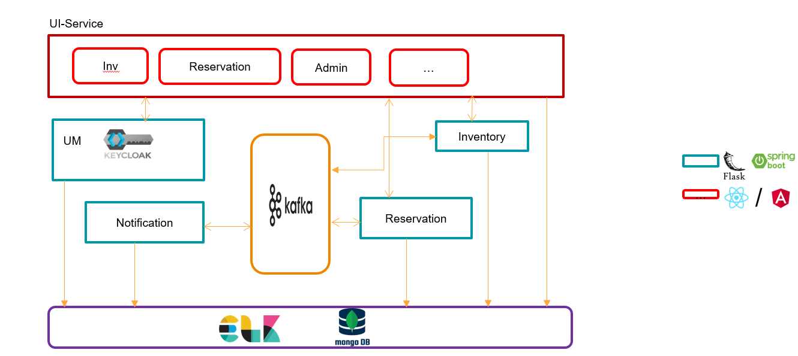

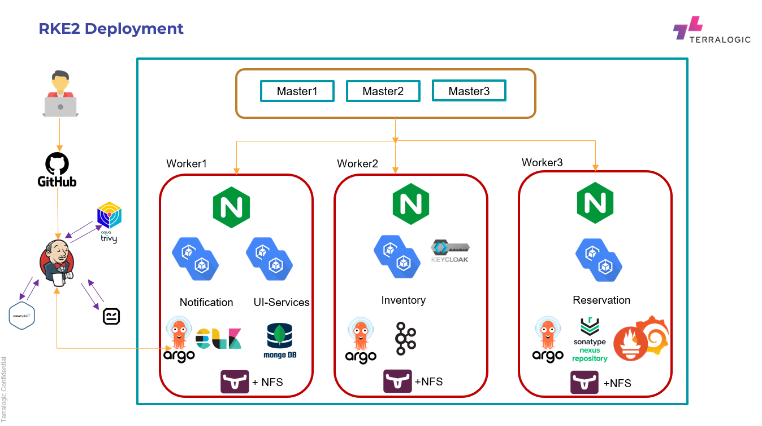

### Schema

This section captures anticipated schema requirements.

**Inventory**

|  |  |  |  |  |  |
| --- | --- | --- | --- | --- | --- |
| inv_logo | inv_id | inv_name | inv_desc | inv_type | inv_blob |
| image | 47586767383838 | “Learning Python” | A book to bootstrap python deployment | BOOK | NA |

|  |  |  |  |
| --- | --- | --- | --- |
| Field Name | Description | Usage | Remarks |
| inv_logo | (Image)  Logo of the inventory | Exposed | Logo depicting the type of inventory from the list  inv_type |
| inv_id | Numeric [32 digits] | Internal & not exposed |  |
| inv_name | String [define max length] | Exposed |  |
| inv_description | String [define max length] | Exposed |  |
| inv_type | Custom Keyword  [BOOK/e-BOOK/VIDEO] | Exposed |  |
| inv_blob | String | Exposed | In case of Book (Image URL reference of Book, URL of e-BOOK, URL of video) |

**Reservation**

|  |  |  |  |  |
| --- | --- | --- | --- | --- |
|  |  |  |  |  |
|  |  |  |  |  |

**Notification**

|  |  |  |  |  |
| --- | --- | --- | --- | --- |
|  |  |  |  |  |
|  |  |  |  |  |

**Administration**

|  |  |  |  |  |
| --- | --- | --- | --- | --- |
|  |  |  |  |  |
|  |  |  |  |  |

**User-Management**

|  |  |  |  |  |
| --- | --- | --- | --- | --- |
|  |  |  |  |  |
|  |  |  |  |  |

### API

The deployment below is a draft design on a Kubernetes orchestration platform.

**Inventory**

CRUD List to be defined here.

**Reservation**

**Notification**

**Administration**

**User-Management**

***End of document***